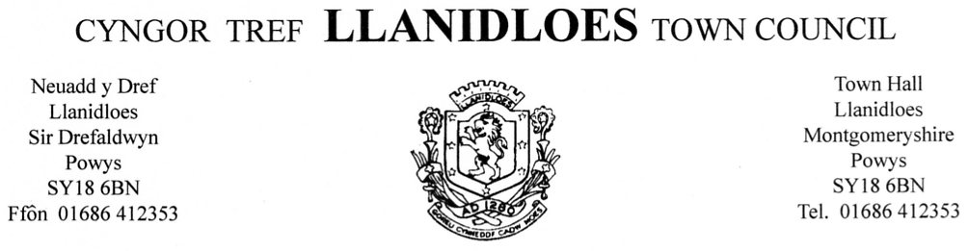

21st September, 2014

To the Town Mayor and Councillors, Llanidloes Town Council, you are summoned to attend a monthly meeting of LLANIDLOES TOWN COUNCIL to be held at the Council Chamber, Town Hall, Llanidloes on Monday 29th September, 2014 at 6.45 p.m.

The business to be transacted is as set out below,

Sonia Pritchard
TOWN CLERK

AGENDA

- To receive information from Ms Lynda Cooke re Management Plans for Allt Goch woods (10 minutes)

- To accept apologies for absence

- To accept personal and pecuniary interests in items of business

- Minutes Council Meeting held on 28.07.14
Environment and Planning Panel meeting held on 08.09.14
Town Hall and Finance Panel meeting held on 08.09.14
Meeting to discuss Biomass Boiler held at Reading Room on 14.08.14
Meeting to discuss Biomass Boiler held at the Council Chamber on 19.08.14
Allt Goch Committee management meetings held on 31.07.14 and 28.08.14

- To receive correspondence:-

- Letter from Wales Rally GB informing of rally taking place on 14th November 2014
- Letter from PCC – Sustainable Library Service
- Newsletter from SARPA (Shrewsbury Aberystwyth Rail Passengers Assoc)
- Letter from Post Office Re Modernisation
- Information from Mynydd y Gwynt Re Notice of Acceptance of an application for a Development Consent Order by the Planning Inspectorate (on behalf of the Secretary of State)
- Invitation from St John Wales to Vintage Fete, and request for funding
- Letter from Mid Wales Orienteering Club and Powys Sports Development asking permission to use Allt Goch for Orienteering day on Friday 10th October, 2014
- Request for funding from Shelter Cymru
- List of 8 motions to be put forward at OVW AGM on 4th October
- E mail from SI Jason Walters (Llanidloes Army Cadets)
- Information from Sirolli Project – rebranded Severn Valley Effect
- Notification of PCC Budget Conversation to be held on 13th October

- To receive information from Student Council

- To discuss future Management of Allt Goch (Cllr Rees)

- To receive issues arising report from BDO (External Auditors) and sign and date Annual Return for Audit 31.03.14

- To discuss Cash Point further to closure of NatWest Bank

- To discuss proposed closure of Public Toilets on Gro

- To discuss letting of Unit at rear of Town Hall

- To discuss Biomass Boiler quotations

- To discuss Local Development Plan further to Councillors viewing at Library

- To discuss any Planning Applications received

- To confirm Accounts:-

JULY 2014

Chq No
100102 JCR Plumbing (Vict Ave Toilets) 410.00
100103 Sarpa (membership) 8.00
100104 JDH Business Services 842.40
100105 Petty Cash 79.34
100106 Inland Revenue 859.08
100107 PC Q 18.37
100108 Sign o Matic (car park sign) 78.47
100109 First Responders (Defibrilator) 900.00
100110 Petty Cash 75.93
100111 Void 00.00
100112 Simon Owen (Vict Ave Toilets) 470.00
100113 Wynnstay Group 69.06
100114 R.W. Smith(Vict Ave Toilets) 200.00
100115 Tir Coed (Camb Mountains award) 3,000.00
100116 Powys Safety Solutions (1st Aid) 144.00

Total £ 7,154.65

AUGUST 2014

100117 Inland Revenue 843.08
100118 Sonia Pritchard (Travel) 45.00
100119 Zurich Insurance 3,005.43
100120 Simon Edmunds (Allt Goch) 418.00
100121 Petty Cash 82.01
100122 Border Janitorial Supplies (De humidifiers) 432.00
100123 Wynnstay 21.79
100124 PC Q 22.87
100125 BT 146.77
100126 Mr Simon Edmunds (Well Lane) 249.00
100127 Petty Cash 88.55
100128 Land Registry 36.00
100129 Viking (stationery) 121.72
100130 OGW 1,320.00

Total £ 6,832.22

- Councillors Questions - (Answers to be found by next meeting if possible)

- To confirm dates for October meetings –
Panel Meetings 13th October
Full Council 27th October

Pursuant to Section 1 (2) of the Public Bodies (Admission to Meetings) Act 1960 it is resolved that because of the confidential nature of the business to be transacted, the public and press leave the meeting during consideration of the following item:-

- To discuss Local Government Pension Plan

